To get access to my FREE online course- Email me at CoachAhsan@Gmail.com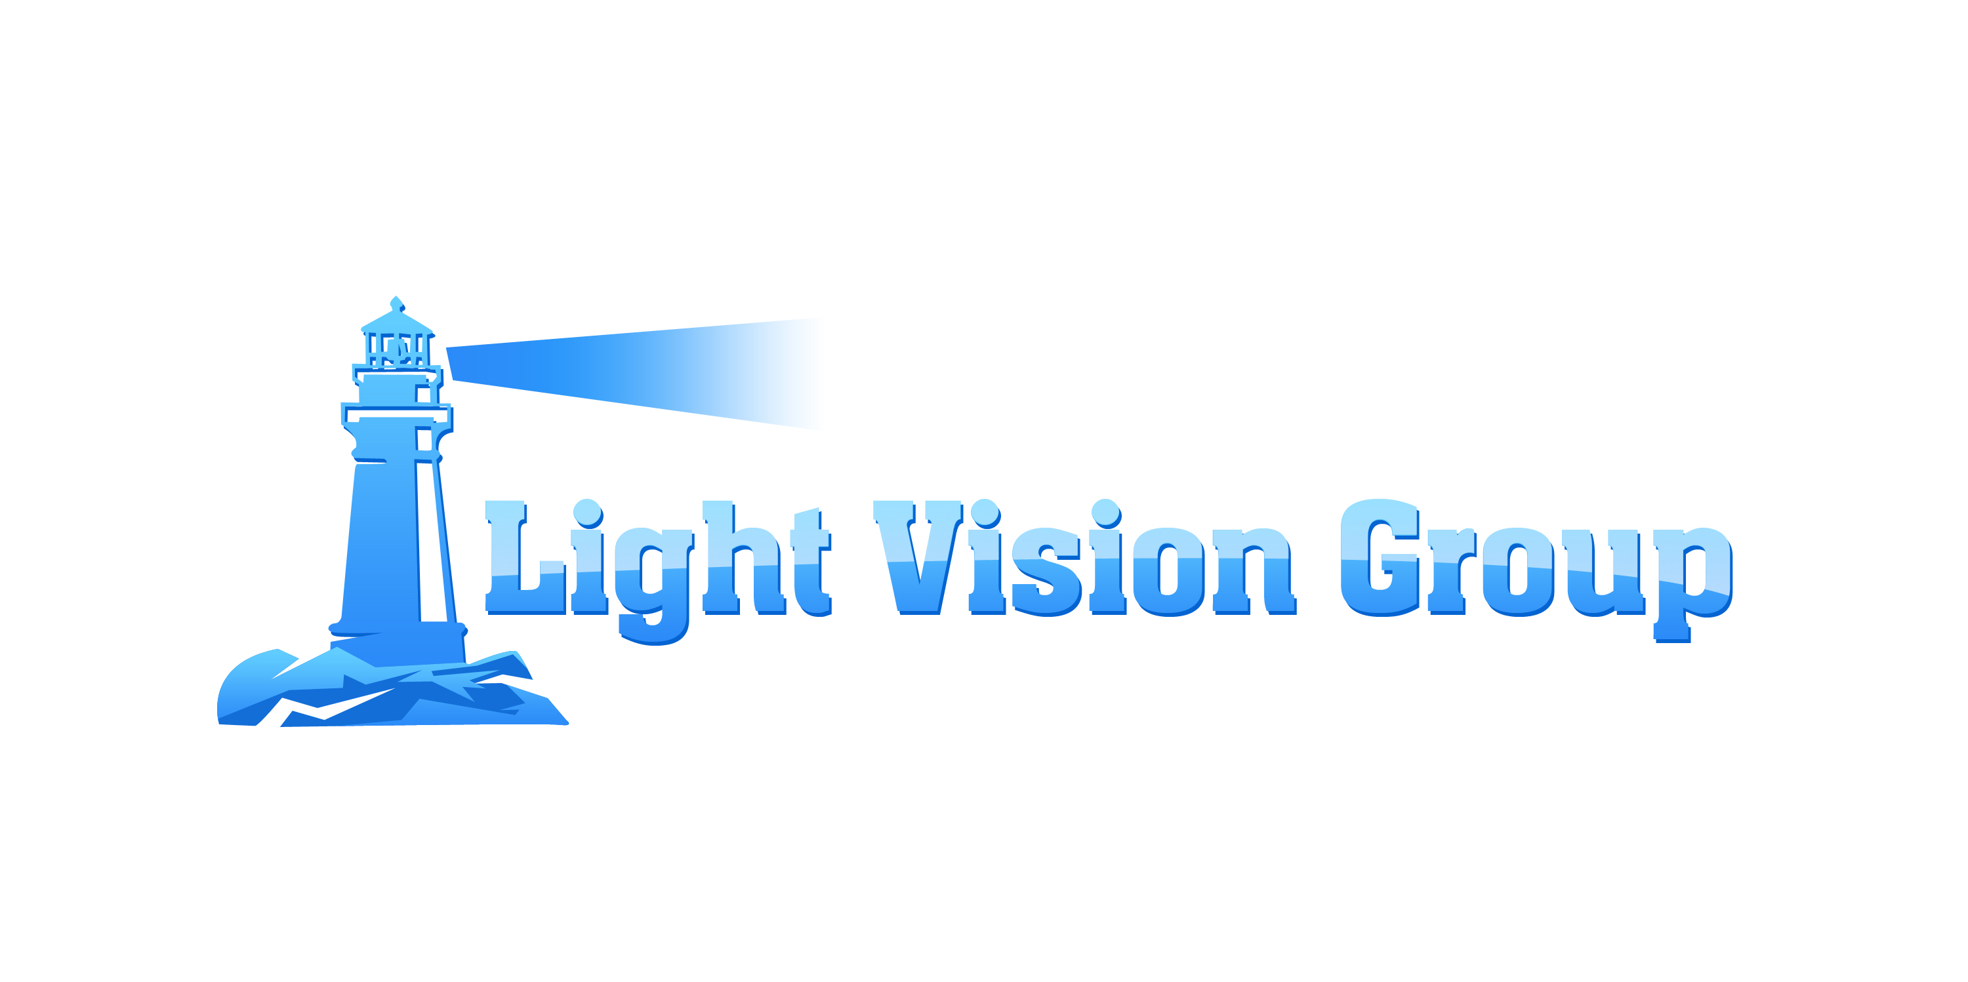  Linkedin Basics  - What is Linkedin?  - World’s largest professional social network  - In more than 200 countries  - 200+ million registered members  - What can Linkedin Do for You?  - Once you join, you create your professional profile  - You add/invite your trusted contacts and build in an ongoing basis  - Linking you to your connections and their connections  - Build your career profile, highlights  - Manage your network  - Gives you access to knowledge, provide opportunities | Add Your Photo  ────  List Jobs, Positions and Descriptions  ────  Add 5 Skills  ────  Complete Summary  ────  Add Your Industry, Postal Code, Education and 50+ Connections  Light Vision Group Inc  773.655.4191  LightVisionGroupInc.com

